**R Code for Examples in the book**

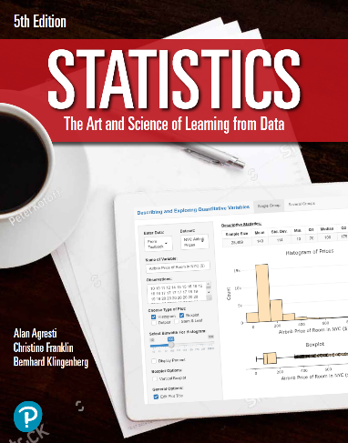

***“Statistics: The Art and Science of Learning from Data”***

**by Agresti, Franklin and Klingenberg, 5th edition**

**Chapter 6**

**Example 13: Testing for Gender Bias – Binomial Distribution**

## To find the probability that 0 women from the management training pool of size 10 are selected for promotion assuming no gender bias

dbinom(0, size = 10, prob = 0.5)

## [1] 0.0009765625